1. Launch one ec2 using Amazon Linux 2 image and add script in user data to install Apache.

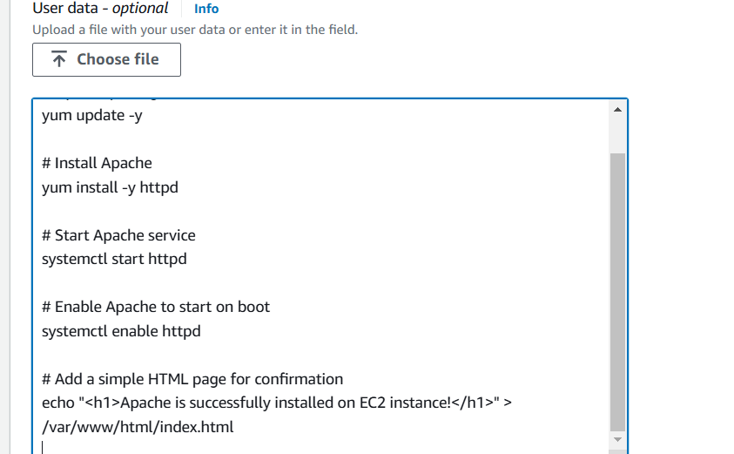

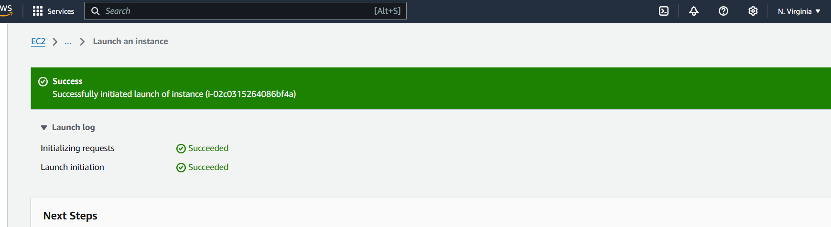

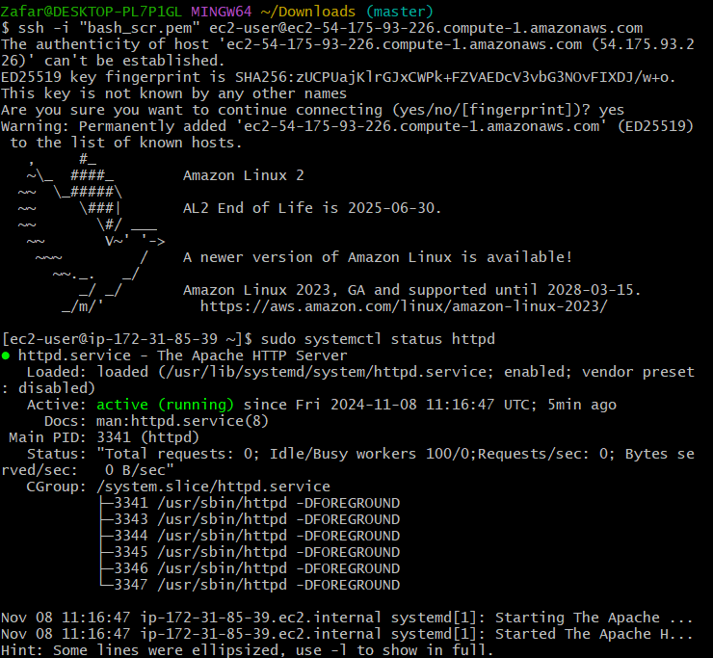

**2) Launch one ec2 using Ubuntu image and add script in user data to install Nginx.**

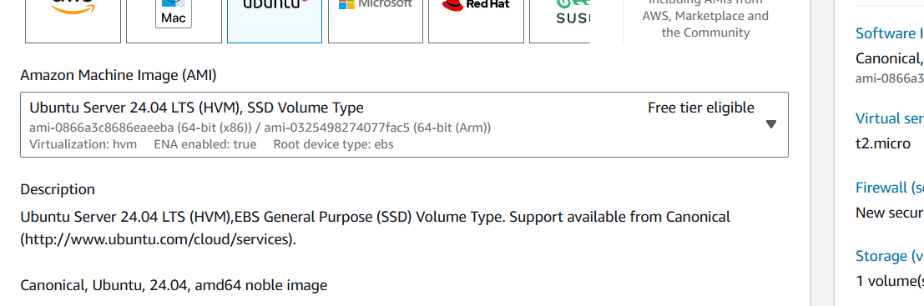

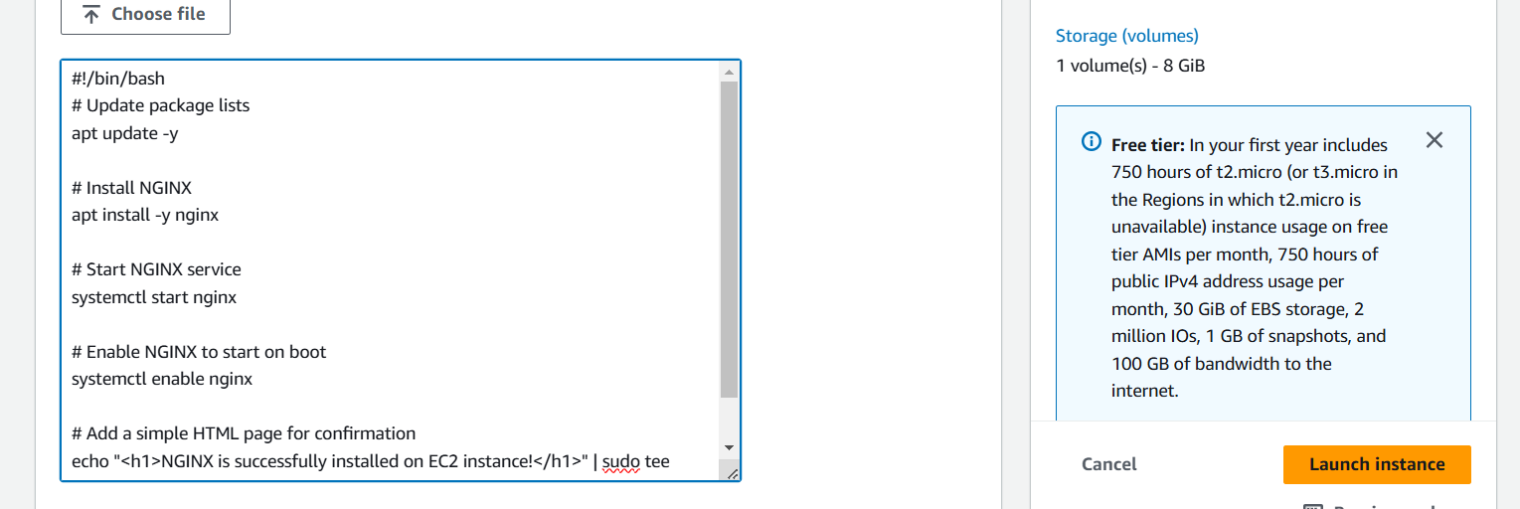

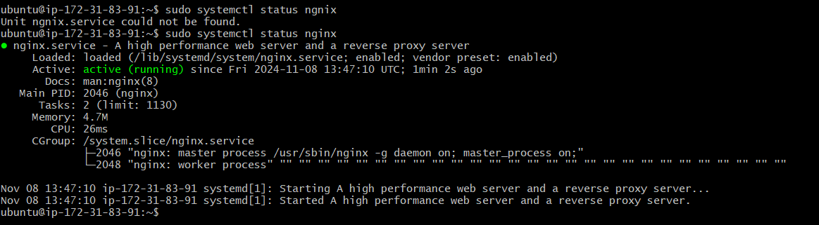

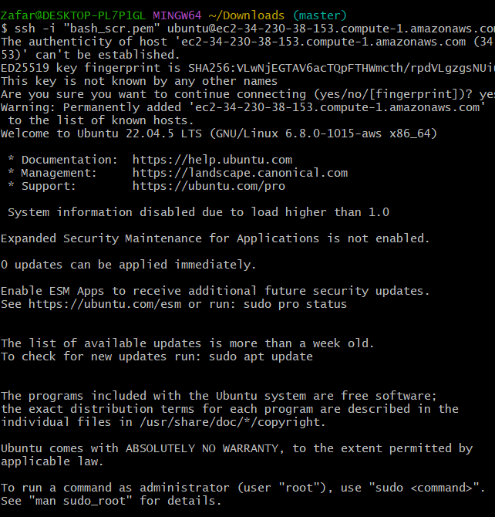

**3)Launch one windows server and install tomcat in windows.**

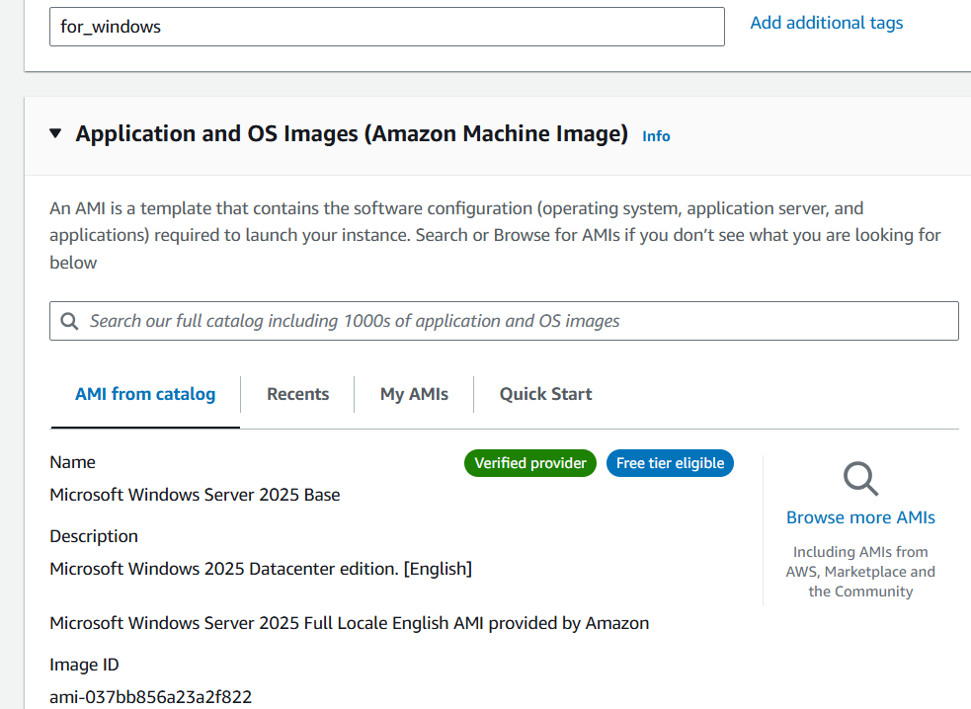

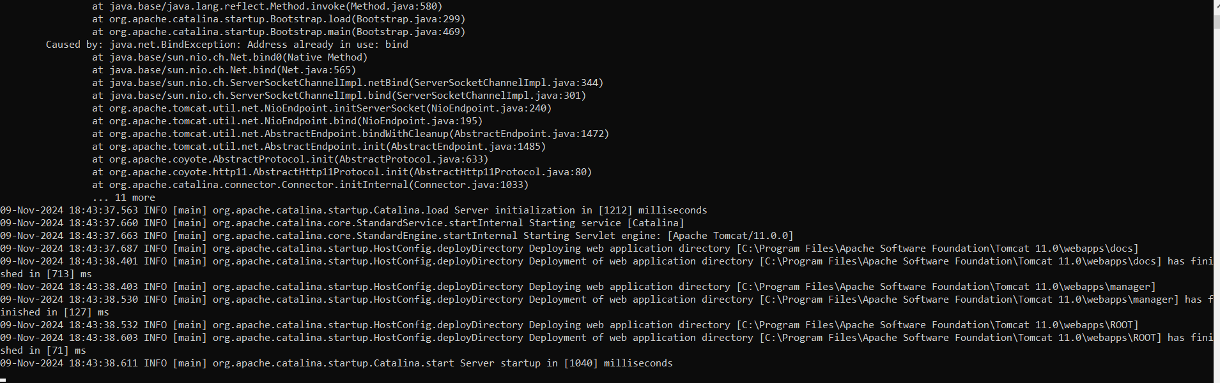

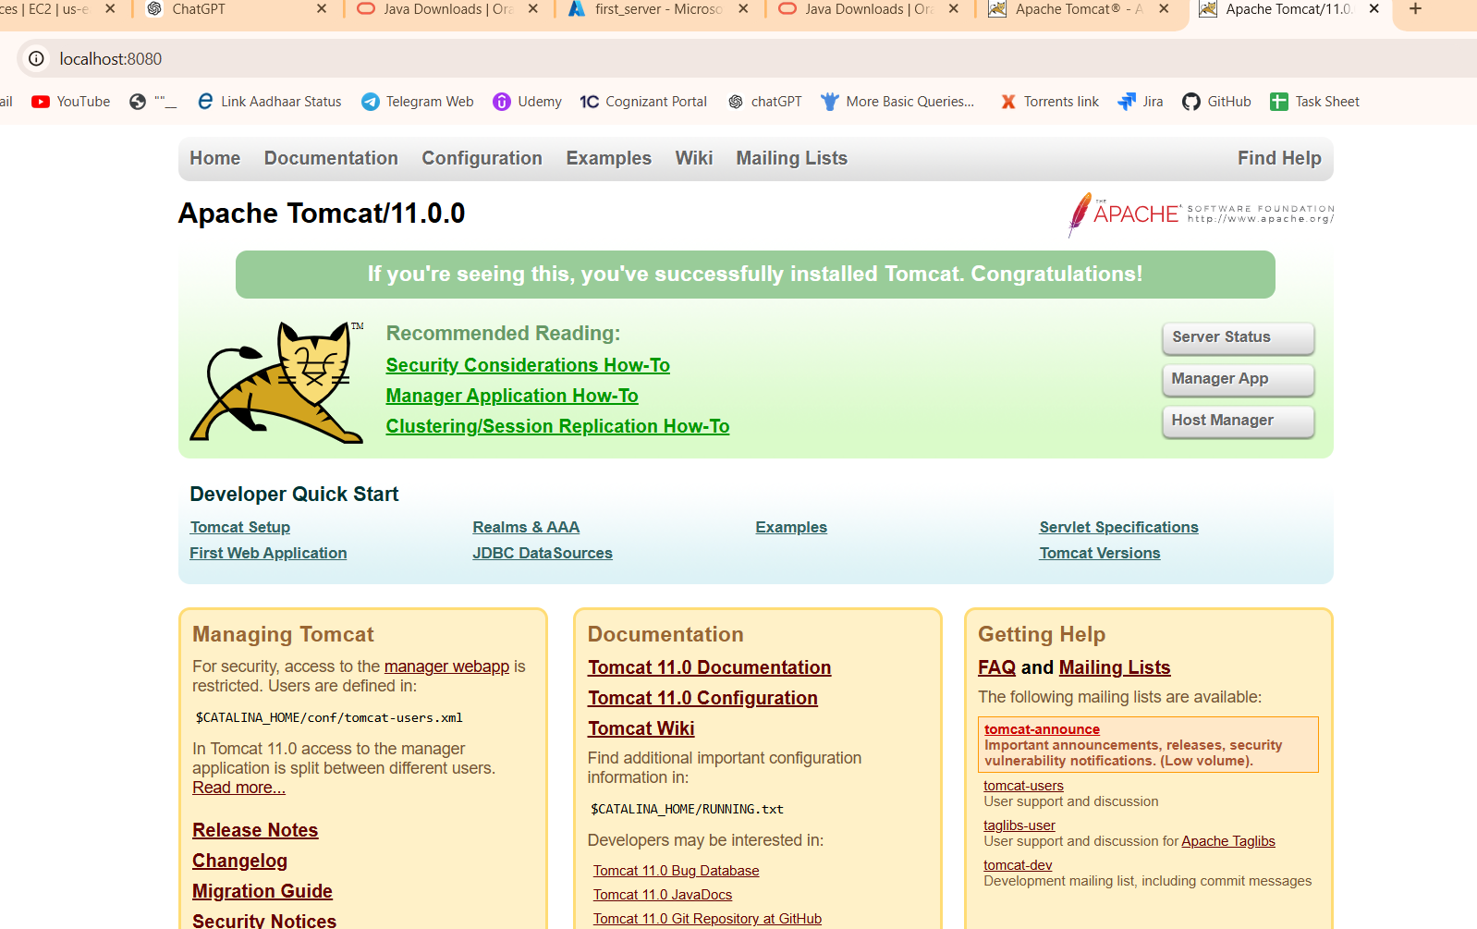

4) Take snapshot of the instane created in Task 1.

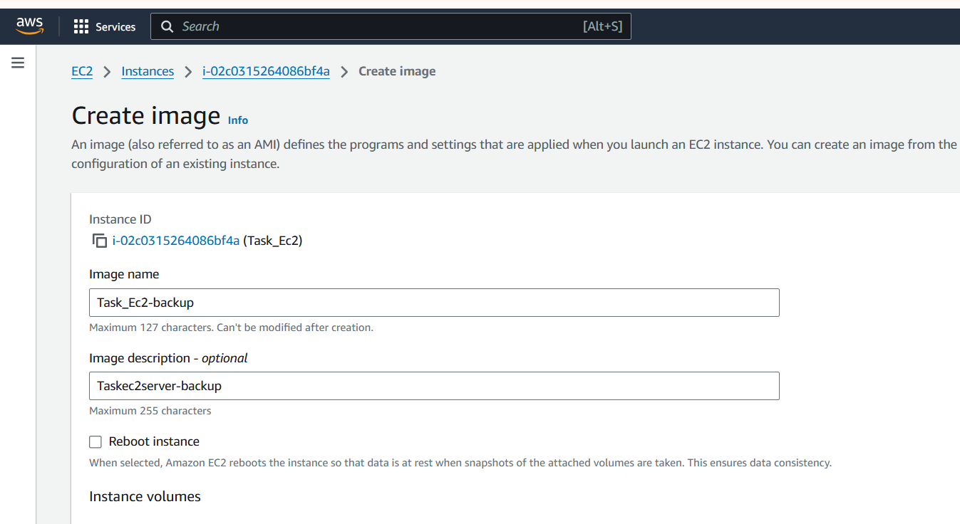

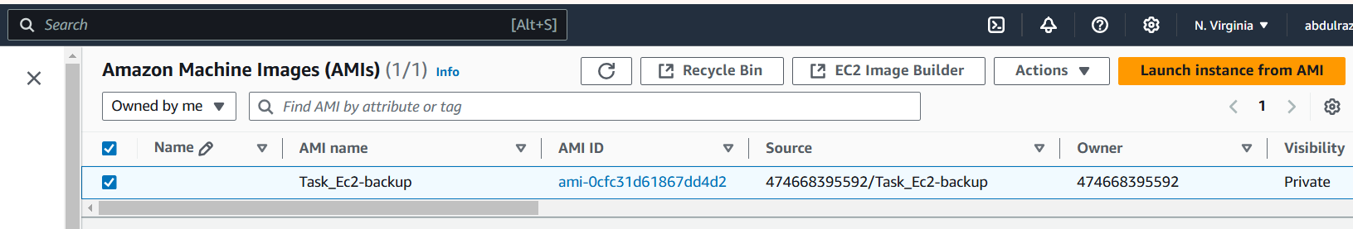

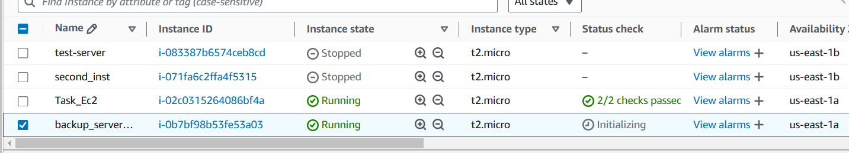

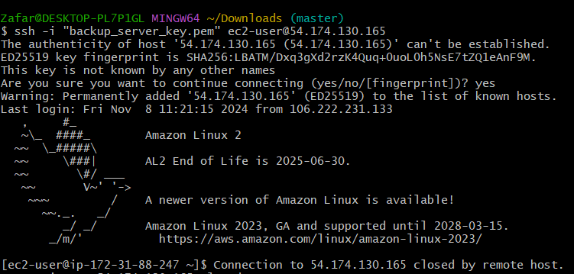

5) Assign password less authentication for ec2 created on Task 2. [Disabled the termination policy for the server with ubuntu image and terminated it before starting this task i.e 5th task. Therefore, assigning password less auth to a different available server.]

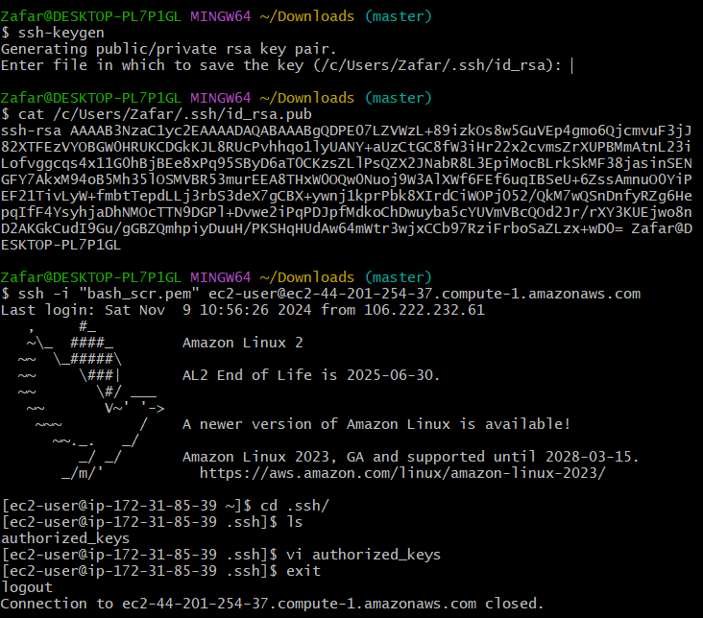

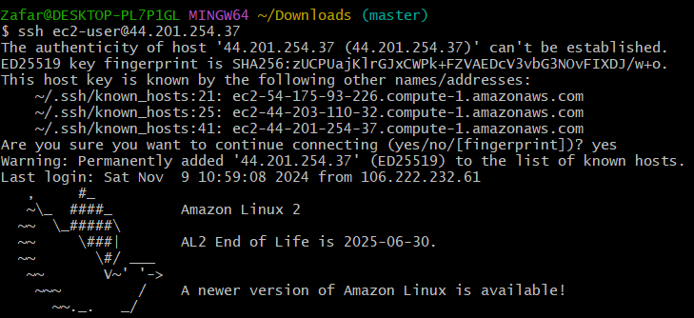

6) Launch any ec2 using spot purchasing option.

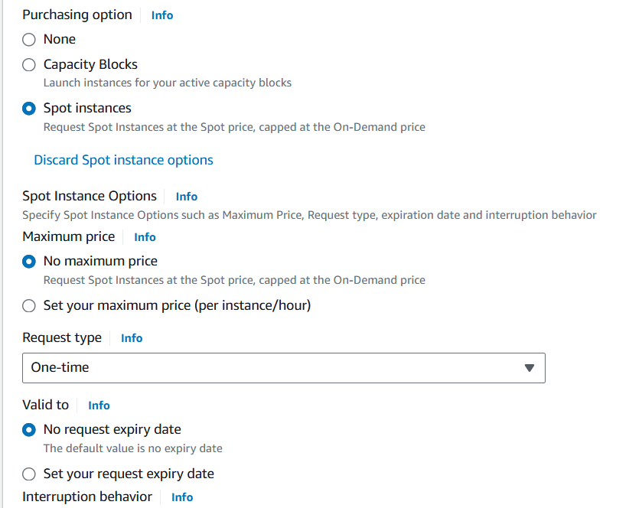

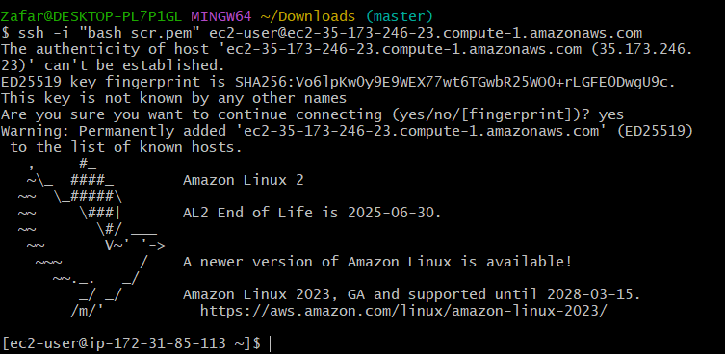

**7) Enable Termination policy on ec2 created in Task 2.**

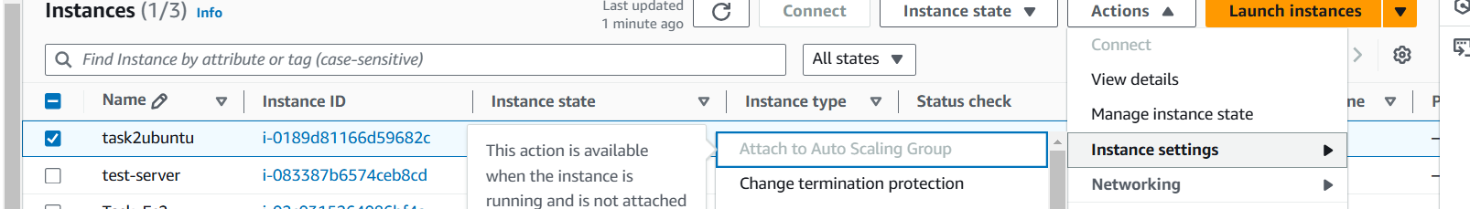

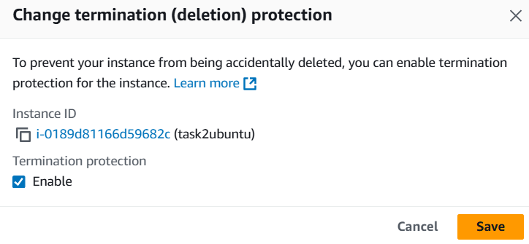

9) Launch one azure VM using ubuntu image

